Chapter 6   
FeRAM

Susanne Hoffmann-Eifert and Takayuki Watanabe

6.1 Principle of FeRAM operation

6.1.1 Information storage and FeRAM configuration

In ferroelectric random access memory (FeRAM), nonvolatility is achieved by the remanent polarization of the ferroelectric (FE) material. The polarization vector P can be reversed by an applied electric field E resulting in a FE hysteresis loop which is shown in Fig. 6.1a. The states of the remanent polarization, (+Pr) or (-Pr), define the logic states ‘1’ or ‘0’ of the memory cell, respectively. The information is written or read by the application of defined voltage pulses. If the applied electrical field is in the same direction as the remanent polarization, no switching occurs, whereas switching occurs if the applied field and remanent polarization are of opposite directions. The respective changes of polarization, either DPns, which is solely due to the dielectric response of the material, or in the case of switching DPs, result in a different transient current behavior of the FE capacitor (see Fig. 6.1b). The integration of the current yields the amount of charge DQ = A DP which is proportional to the change in polarization DP = 2 Pr, where A defines the area of the capacitor. The difference in charge, either DQns or DQs, enables a distinction to be made between the logic states of the FE capacitor. One important criterion for FeRAM device application is the differentiation between the switching ‘s’ and non-switching ‘ns’ state of the FE capacitor during read-out. In order to avoid read failures, the switched charge DQs should not fall below a critical value of *30 fC. Thus, when the cell size of the FeRAM capacitor

S. Hoffmann-Eifert (&)   
Peter Grünberg Institute, Forschungszentrum Jülich, Jülich, Germany e-mail: su.hoffmann@fz-juelich.de

T. Watanabe   
Corporate R&D Headquarters, CANON Inc, Tokyo, Japan

C. S. Hwang (ed.), Atomic Layer Deposition for Semiconductors, 149 DOI: 10.1007/978-1-4614-8054-9_6,  
� Springer Science+Business Media New York 2014

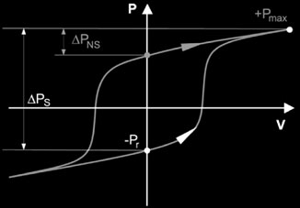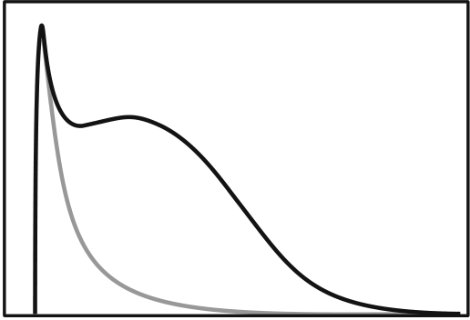

|  |  |  |  |  |
| --- | --- | --- | --- | --- |
| 150 | ***P*** | + *P*max | **(b)** | S. Hoffmann-Eifert and T. Watanabe |
| **(a)** |

Δ *P*ns

|  |  |  |  |  |  |  |  |
| --- | --- | --- | --- | --- | --- | --- | --- |
| Δ *P*s | - *P*r | + *P*r | ***E*** | Current | t0 | switching | Time |
| non- |
| switching |

Fig. 6.1 a Change of the polarization of a ferroelectric capacitor for a non-switching (ns) and a switching (s) event. b Current response of non-switching and switching case of the FE polarization

is reduced in order to increase the integration density, the sensing margin must be ensured by increasing either A or DP. The capacitor area A can be increased by modification of the capacitor’s design from a planar structure to a three-dimen-sional (3D) structure, such as deep trench. The switching charge DQs can be increased by controlling the crystal orientation or by substituting a small DP FE material with a large DP one.

FE memory cells are introduced in various configurations that differ in the number of transistors and capacitors used. Regarding the FeRAM designs, the one transistor-one capacitor (1T-1C) cell exhibits the smallest size and is therefore the most extensively investigated [3, 4]. The single 1T cell represents the ferroelectric field effect transistors (FeFET). Figure 6.2 shows a sketch of a simplified 1T-1C FeRAM cell, which is more complex than a corresponding 1T-1C dynamic random access memory (DRAM) cell as it is not only addressed by word lines and bit lines, but needs one additional drive line (or cell plate) for switching purposes. The function of each line is defined in the schemes for writing and reading which are explained for example in Refs. [5, 6].

For ‘writing’ it has to be ensured that the voltage across the FE capacitor is larger than the coercive voltage. The ‘reading’ of the logic state of the storage capacitor is done by means of a sense amplifier that compares the voltage on the bit line, which depends on the values of the capacitors, CBL and CFE, to a reference voltage. For logic state ‘‘1’’ the signal is amplified, for logic state ‘‘0’’ it is set to 0 V. This operation is destructive and the data must be restored after reading.

6.1.2 Ferroelectric Materials for FeRAMs

FE oxides which are intensively investigated for application in memory devices mostly exhibit either a perovskite-type structure such as lead zirconate titanate, Pb(ZrxTi1-x)O3 (PZT) [7], or layered perovskite structure as for example stron-tium bismuth tantalate, SrBi2Ta2O9 (SBT), and bismuth lanthanum titanate,

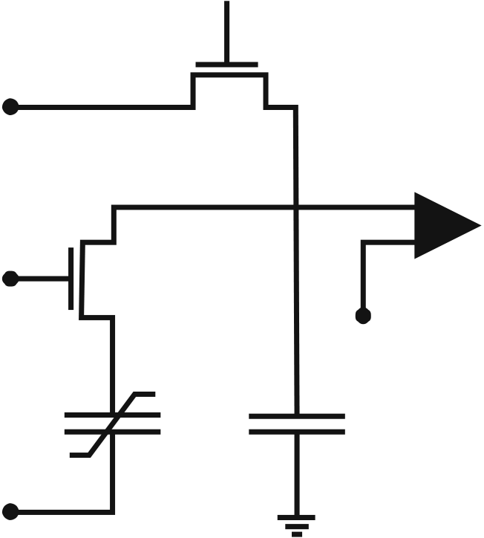

|  |  |  |  |  |
| --- | --- | --- | --- | --- |
| 6 | FeRAM | **Bit line** | **Read / Write** | 151 |
| Fig. 6.2 Simplified 1T-1C | |
| FE memory circuit | | **enable** | **Sense** |
| **amplifier** |

**Word line**

**Vref**

**CFE**  **CBL**

**Drive line**

(Bi1-xLax)4Ti3O12 (BLT) (see e.g. [2, 8–10]). For more details see also topical books [11–13].

Oxide FEs must attain a crystalline perovskite-type structure in order to display hysteretic polarization behavior. Thus, crystallization temperature and atmosphere are critical parameters for the integration of the thin films. In addition, due to the non-centro-symmetric structures of the unit cells, which are inherent to FEs, a certain texture of the thin films is required in order to switch the polarization vector in the electric field applied by the electrodes. Figure 6.3 summarizes the differences in the cell structures of PZT and SBT, which to some extent determine the characteristics of the FE materials. PZT (see Fig. 6.3a) exhibits different FE properties depending on the type of structural distortion [14]. Below the Curie temperature, the material undergoes a morphotropic phase transition from the tetragonal to rhombohedral state when the composition is changed from Ti-rich to Zr-rich, respectively. In the tetragonal phase, e.g., PZT (30/70), the polarization vector lies in the [001] direction, while for the rhombohedral phase, e.g., PZT (60/ 40), the polarization vector is oriented along the [111] direction. For FE memory applications, the tetragonal phase of PZT is favored over the rhombohedral phase because of its higher Pr values and its squarer hysteresis loops [15]. In addition, the crystallization temperature of the Ti-rich phase is lower than that of the Zr-rich composition which makes the integration of Ti-rich PZT thin films easier. The sensitivity of the FE properties of PZT to the composition and texture makes a precise deposition process indispensable, especially if PZT is to be deposited on narrow 3D structures [16, 17].

SrBi2Ta2O9 (SBT; see Fig. 6.3b) is a prominent representative of FE material with an Aurivillius-type phase. [2] This structure can be visualized as pseudo-perovskite layers separated by (Bi2O2)2+layers. The bismuth layer structure can be

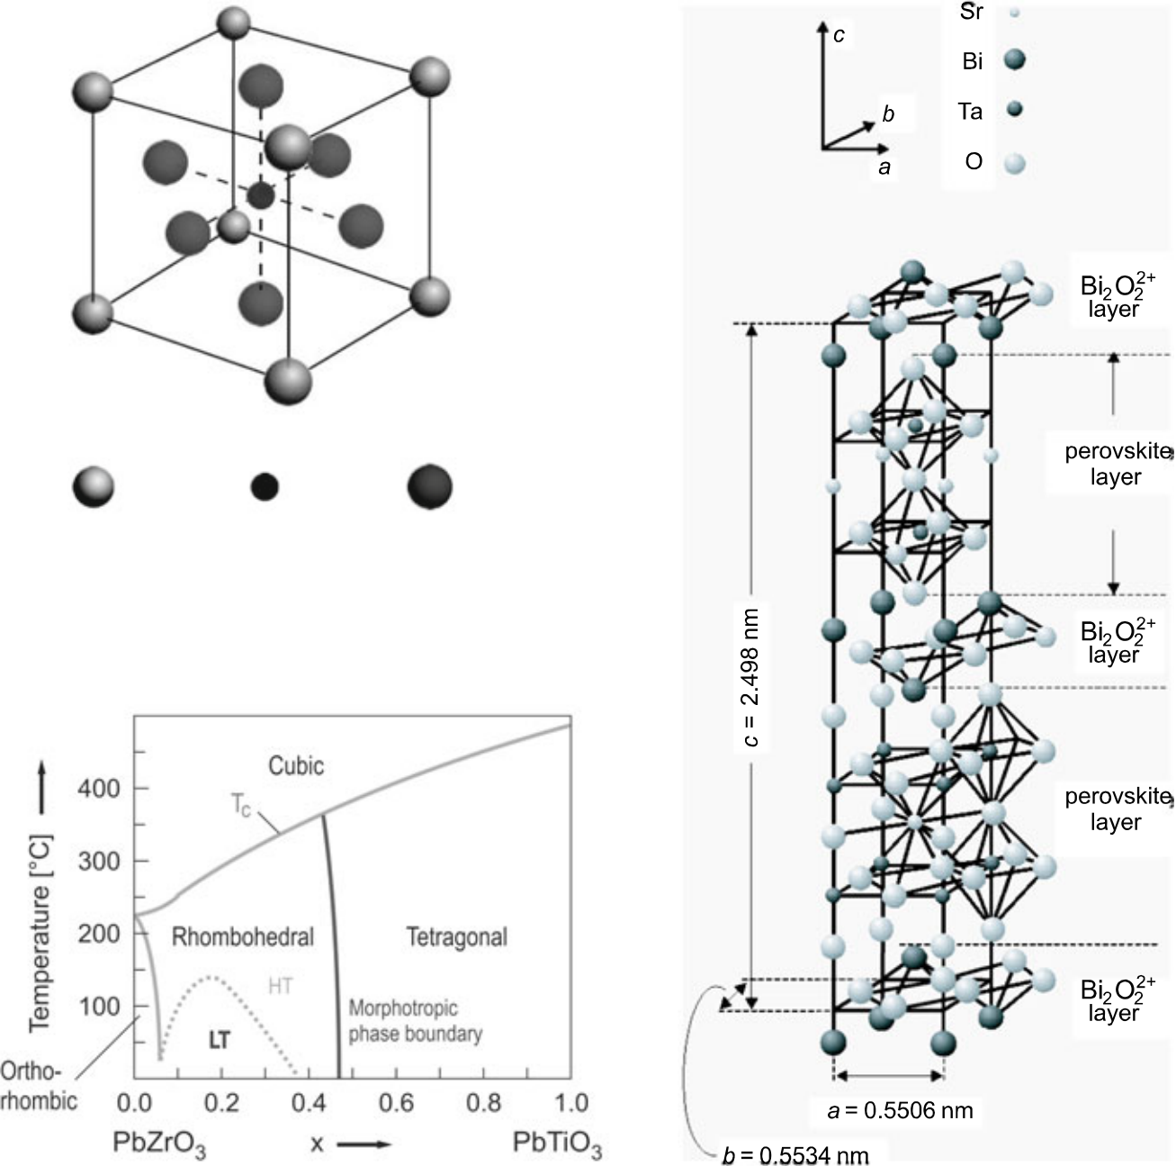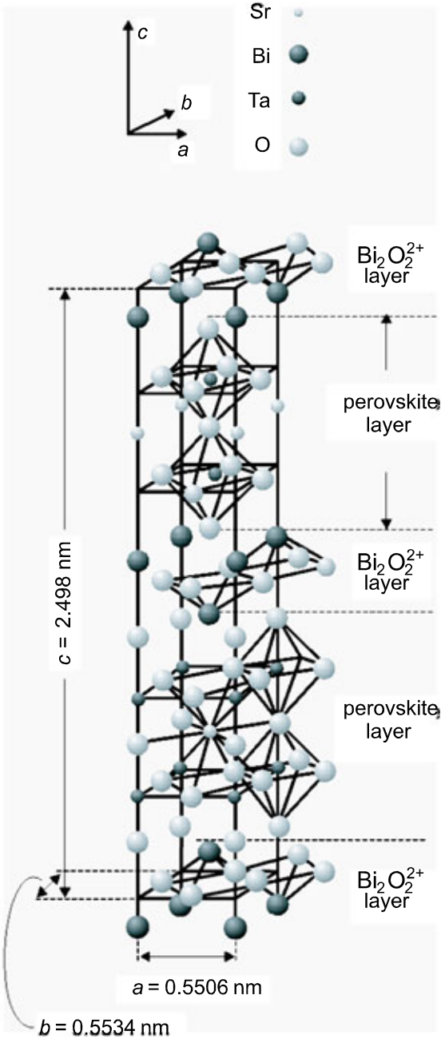

|  |  |  |  |  |
| --- | --- | --- | --- | --- |
| 152 | Pb2+ | Zr4+/ Ti4+ | O2- | S. Hoffmann-Eifert and T. Watanabe |
| **(a)** | **(b)** |

Fig. 6.3 Typical FE materials; a Perovskite structure and phase diagram of Pb(ZrxTi1-x)O3 and b layered structure of Aurivillius-type SrBi2Ta2O9 (Reprinted with permission from [21].

Copyright 2005, WILEY-VCH Verlag GmbH & Co. KGaA, Berlin)

stabilized in various layer configurations of different stoichiometry [18]. Due to the comparatively few directions allowed for spontaneous polarization, the switchable polarization of polycrystalline bismuth layer structured films is rather small compared to lead-based perovskite films.

The operation voltage of the device has to be greater than the coercive voltage, which is inherent to the integrated FE material. In this respect, FEs of the Auri-villius family are superior to lead-based perovskites because of the lower coercive field [19, 20]. For further reduction of the operation voltage, the FE layer has to be thinned, while any inhomogeneities like variation of film thickness, small pores, or contamination by a non-FE impurity phase due to the off-stoichiometry will be exaggerated and can readily cause serious failure. Consequently, as the FE layer becomes thinner, a more precise deposition process which can produce

|  |  |  |
| --- | --- | --- |
| 6 | FeRAM | 153 |

Table 6.1 Properties of typical ferroelectrics used for FeRAM taken from Ref. [6]

|  |  |  |  |  |
| --- | --- | --- | --- | --- |
| Ferroelectric material | | Pb(ZrxTi1-x)O3 | SrBi2Ta2O9 | (Bi,La)4Ti3O12 |
| Remanent polarization [lC/cm2] | | 10–40 | 5–10 | 10–15 |
| Coercive field [kV/cm] | | 50–70 | 30–50 | 30–50 |
| Crystallization temperature [�C] | | 450–650 | 650–800 | 650–750 |
| Endurance | On Pt electrode | Poor | Good |
| On oxide electrode | | Good |

homogenous thin FE layers is necessary. Note that the FE film is grown on 3D structures in order to maintain sufficient switching charge for sensing.

Some representative properties of these materials utilized in FeRAM devices are summarized in Table 6.1. More data on commercially available FeRAM products of medium integration density can be found from e.g., Ramtron [22], Symetrix [23], Texas Instruments [24], and Fujitsu Ltd. Electronic Devices [25].

6.1.3 Electrode Materials

In general, the FE oxides are deposited in oxygen-rich atmosphere at temperatures between 550 and 800 �C. Therefore, the electrode as well as the plug materials to be used for FeRAM devices must be resistant to oxidation and inert in contact with the FE material, which means that no uncontrolled interdiffusion of metal ions may occur and that no intermediate layers may be formed deteriorating device per-formance. This requirement is fulfilled by noble metals such as Pt, by metals which form a conductive oxide, such as Ir–IrO2 and Ru–RuO2, and by conductive oxides such as SrRuO3. Like the FE layer, these electrode layers must be deposited uniformly in order to avoid any electrical errors. For deposition of metals and conducting oxides by atomic layer deposition (ALD) see articles such as [26–28].

6.2 Trends in Ferroelectric Random Access Memories

6.2.1 Planar Ferroelectric Capacitor Stacks for Medium Integration Density

Most of the applications of commercialized FeRAMs are in the area of low-density memory for NV portable applications, as for example electronic passports and other types of e-cards [29]. Today’s ‘standard’ method for the growth of PZT thin films in integrated FeRAM cells of up to 64 Mb density is metal organic chemical vapor deposition (MOCVD) [30–34]. Figures 6.4a and b show cross sections of planar FE capacitors fully integrated into a 1T-1C structure and a planar FE capacitor after optimization of the etching procedure.

154 S. Hoffmann-Eifert and T. Watanabe

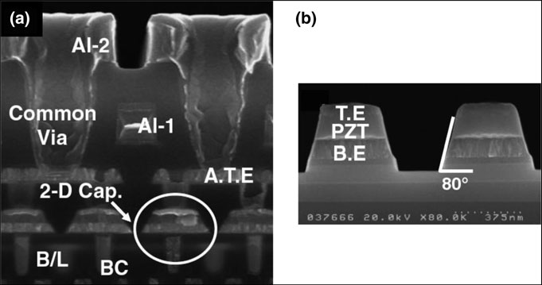

Fig. 6.4 Vertical SEM cross sections of planar FE capacitors (2D-Cap.) from metal/MOCVD PZT/metal stacks: a Fully integrated in a 1T-1C FeRAM structure and b Standalone cells with optimized side wall steepness (Reprinted with permission from [34]. Copyright 2006, The Japan Society of Applied Physics)

For higher integration densities, the FeRAM cells are expected to ‘follow’ the trend of the DRAM cells by utilizing multi-stacked or trench cells in order to increase the effective capacitor area at a fixed cell size. A graphical summary of a possible scaling scenario of future FeRAMs, suggested in Ref. [1] based on the ITRS road map [35], is shown in Fig. 6.5. The feature size for which a 3D structure of the FE capacitor will become necessary has been estimated and the result is expressed in the 3D folding factor in Fig. 6.5. From this it is expected that FeRAMs above the 256 Mb generations would be based on nonplanar FE capacitor technologies.

6.2.2 Transition from 2D to 3D FE Capacitor for High-Density Integration

Researchers at Samsung Advanced Institute of Technology (SAIT) demonstrated a prototype 3D FE capacitor cell in 2004 [36, 37]. The device structure was built in SiO2 capacitor holes of 0.32 lm and 0.25 lm in diameter, respectively, with a depth of about 0.6 lm and consisted of an ALD Ir bottom electrode, a 60 nm thick MOCVD PZT film, and an ALD Ir top electrode (see Fig. 6.6a) [34]. The 0.32 lm trench FE capacitor showed FE properties similar to the corresponding planar stack with a 2Pr value of 24 lC/cm2at an external bias voltage of 2.1 V. However, in the 0.25 lm trench diameter capacitor 2Pr was decreased to 19 lC/cm2(see Fig. 6.6b) [6].

|  |  |  |
| --- | --- | --- |
| 6 | FeRAM | 155 |

A careful and comprehensive microstructure analysis of the device cross sec-tions [38] revealed a possible inherent limitation of the MOCVD processing, namely the inability of conformal growth of multicomponent thin films with homogeneous stoichiometry into 3D structures. In detail, it was found for the MOCVD PZT films in the 0.32 lm trench that the columnar perovskite PZT grains were well established on the side walls of the trench, while at the bottom a fine-grained non-FE pyrochlore-type phase was detected as depicted in Fig. 6.7a. The decrease of remanent polarization with decreasing trench diameter (see Fig. 6.6b) was attributed to an incomplete extension of the columnar perovskite-type grains on the 0.25 lm trench side walls as was proven from synchrotron X-ray micro-diffraction analysis [38] and careful TEM studies [34] (see Fig. 6.7b).

Thus, the development of a technology for conformal deposition of perovskite-type FE PZT films with controlled stoichiometry and microstructure was identified as one of the key technical challenges for the development of a 3D FE capacitor essential for 6–8 F2cell FeRAMs beyond the 100 nm technology node.

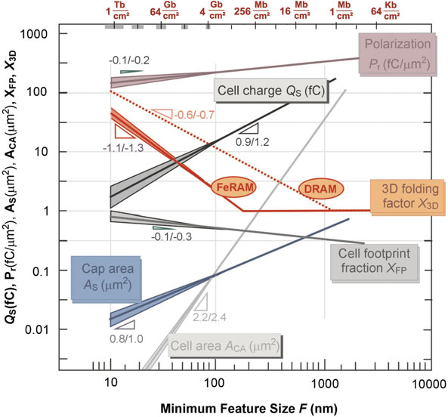

Fig. 6.5 Roadmap of future FeRAM devices [1]. Copyright Wiley-VCH Verlag GmbH & Co. KGaA. Reproduced with permission

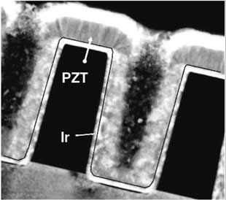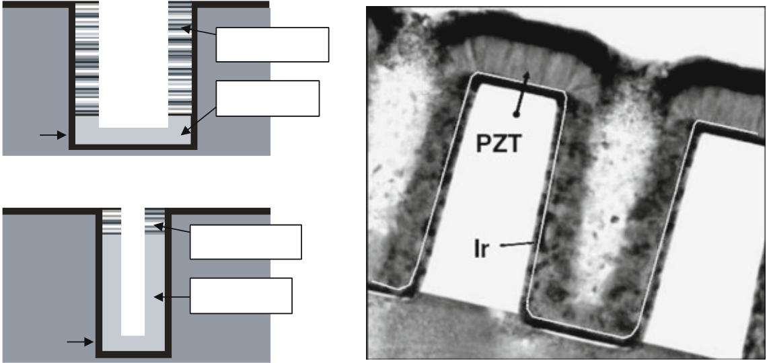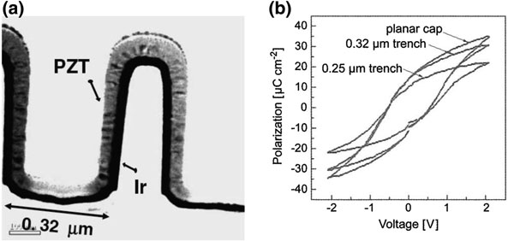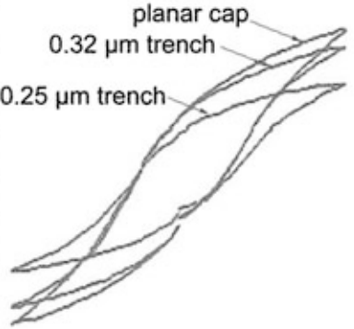

156 S. Hoffmann-Eifert and T. Watanabe

Fig. 6.6 a TEM image of a 3D MOCVD PZT/ALD Ir capacitor deposited in a trench hole of 0.32 lm diameter (Reprinted with permission from [34]. Copyright 2006, The Japan Society of Applied Physics). b Measured (P–V) loops for 3D FeRAM cell structures with different trench diameters [6]. Copyright Wiley-VCH Verlag GmbH & Co. KGaA. Reproduced with permission

**(a)**  **(b)**

**Columnar**   
**SiO2**   
 **Granular**

**Ir**

**Columnar**

|  |  |
| --- | --- |
| **SiO2** | **Granular** |

**Ir**

Fig. 6.7 Grain structure in 3D FE capacitors from MOCVD-grown PZT layer and ALD Ir electrodes. a Schematic drawing of the distribution of perovskite- and pyrochlore-type phase. b TEM image of cross section of ALD Ir/MOCVD PZT/ALD Ir capacitor on SiO2 trench holes of 0.25 lm in diameter (Reprinted with permission from [34]. Copyright 2006, The Japan Society of Applied Physics)

6.3 Atomic Layer Deposition of Multicomponent Oxides on 3D Structures

6.3.1 State of the Art of Multicomponent Oxides ALD

The intensive research on the integration of FE capacitors into 3D structures for high-density NV memory devices clearly revealed that for the realization of Fe-RAMs beyond the 100 nm technology node a deposition process has to be

|  |  |  |
| --- | --- | --- |
| 6 | FeRAM | 157 |

developed, which offers the ability of conformal growth of stoichiometric films onto challenging 3D structures, even for a multicomponent FE oxide. With respect to the integration of high-k oxides for DRAM applications (see [Chap. 4](http://dx.doi.org/10.1007/978-1-4614-8054-9_4)), the ALD technique has become established as the standard technique for 3D growth of functional oxides. The principle of ALD and the criteria for the definition of an ALD-type growth process have been intensively discussed in the previous chap-ters. Therefore, this paragraph will be restricted to ALD processes for FE oxide thin films for FeRAM applications.

Despite the strong interest in 3D FE capacitor structures, the number of studies on ALD of multicomponent FE oxides as SrBi2Ta2O9 (SBT) [39] or lead-based perovskites [40–50] is rather limited. While Harjuoja et al. [40, 41], Hwang et al. [42], and Lee et al. [43] reported on ternary systems PbTiO3 and PbZrO3, Wa-tanabe et al. combined all three binary oxide processes, namely PbO, ZrO2, and TiO2, to develop an ALD process for the quaternary Pb(Zr,Ti)O3 compound [46–50].

In the following, we will recapitulate important steps in the development of the thermal ALD process for PZT thin films and their integration into 3D structures for future FeRAM devices.

6.3.2 ALD Process for Multicomponent Ferroelectric Oxide

Figure 6.8 depicts a special source gas supply sequence for ALD of thin films from the quaternary compound Pb(Zr,Ti)O3, which is a combination of binary ALD processes for PbO, TiO2, and ZrO2. The self-regulated growth is very sensitive to the ligand structure of the precursor molecule, while it is easily altered once a precursor is mixed with other precursors in the gas phase. To avoid any type of interaction of precursors in the gas phase, the reactants are supplied independently into the deposition chamber. The binary processes will each be repeated several times to adjust the cation composition as necessary. Hence, the self-regulated growth, which is the most characteristic benefit to ALD, must be achieved on both another pre-deposited cation layer and the layer itself.

6.3.3 Precursors for ALD

FEs considered for FeRAM applications are multicomponent oxides that typically consist of three kinds of metals and oxygen. Consequently, an ideal precursor would have all component elements in one molecule. The metal composition in the molecule would be designed according to the target composition of the deposited film. This idea has been partially achieved, for example, for the Sr–Ta double alkoxide precursors used in MOCVD and even ALD processes [51]. However, such ideal precursors are not always available. Consequently, the ALD process for

158 S. Hoffmann-Eifert and T. Watanabe

**Binary**

|  |  |  |  |  |
| --- | --- | --- | --- | --- |
| Precursor-A | **Zr** | **process-A** | **Binary** | **Binary** |
| **(PbO x)** | **process-B** |
| **(TiO x)** | **process-C** |
| **Pb** |
| **(ZrO x)** |
| Precursor-B | **Ti** | **Zr** |
| Precursor-C |

Reactant (H2O)

Purge



One sequence

|  |  |  |  |  |  |  |
| --- | --- | --- | --- | --- | --- | --- |
| Source-A | Purge & | | Source-B | Purge & | Sub nano | After |
| supply | oxidation | supply | | oxidation | stacking | annealing |
|  | | | | | -A-B-A-B- | |  |  |  |  |  | | --- | --- | --- | --- | --- | |  |  |  |  |  | |  |  | |
| |  |  |  |  |  |  | | --- | --- | --- | --- | --- | --- | |  | | |  |  | | |  | |  |  |  | |  |  |  |  |  | |  |  |  |  |  |  | |

|  |  |  |
| --- | --- | --- |
| 6 | FeRAM | 159 |

(2) Thermal stability and compatibility with other precursors

On the one hand, the higher the substrate temperature is, the higher deposition rate is expected to be. On the other hand, a self-regulated process will be lost once the precursor molecule decomposes thermally at too high deposition temperature. The substrate temperature is thus limited below the lowest thermal decomposition temperature of any of the precursors. Therefore, precursors that decompose at high temperature may be chosen, with the restriction that for multicomponent ALD the decomposition temperatures of the precursors are within the same regime. The thermal decomposition temperature of each precursor should be determined via a pre-study ALD of their binary oxide or from thermal decomposition analysis. The required FE film thicknesses will be around 10–30 nm, which is thicker compared with gate dielectric, so that the process time will be longer. In order to shorten the process time, it is advantageous to use precursors with a high thermal decompo-sition temperature.

(3) Self-regulated growth

In multicomponent oxide ALD processes the precursors should be introduced into the chamber separately in order to avoid any cross-reactions in the gas phase. Therefore, the self-regulated growth of the component binary ALD will have to be established on at least two kinds of surfaces. One is the layer of the predeposited other metal oxide, and the second is the layer of the material itself.

(4) Reactivity with oxygen source

Before the pulse of oxygen source is introduced into the chamber, the chemi-sorbed surface metal elements still hold a part of their ligands. Therefore, the surface layer must react with the oxygen source to form the metal oxide layer and to remove the unnecessary ligand part. If the reaction with the oxygen source is insufficient, the precursor may leave impurities such as carbon in the film. The contamination may remain even after a crystallization annealing process and thus degrade the insulation property of the FEs. Consequently, the precursor must have a high reactivity with a chosen oxygen source such as H2O, O2, and O3 gases.

6.4 Case Study

6.4.1 Example of ALD-PZT

An ALD system equipped with a pulsed LI vaporizer with three independent liquid precursors and a horizontal gas flow reactor was used for this study. The discrete precursor injection prevents the precursors from pre-reacting in the gas phase. Due

160 S. Hoffmann-Eifert and T. Watanabe

to the narrow selectivity of Pb-, Ti-, and Zr-precursors and their limited thermal stability, LD source injection methods were favored, where precursor solutions are pulse sprayed into a vaporizer kept at 150–200 �C and thermally evaporated. This method is well established for MOCVD processes, but it is not very often applied in ALD-type processes [52]. The LI principle is free from long-term thermal degradation of precursors, which allows the operating lifetime of the precursors to be lengthened in comparison to bubbler-based techniques. All precursors were dissolved in ethylcyclohexane (C6H11C2H5) with a concentration of about 0.05–0.1 mol/l. In order to avoid lead loss during the PZT film growth by for-mation of the volatile and toxic higher oxidized species of lead oxide, water vapor was chosen as the oxygen source in preference to either ozone or oxygen plasma.

The reactor pressure was set to 1.0 Torr and argon was used as carrier gas.

6.4.2 ALD-Type Processes for PZT Films Utilizing Different Precursor Combinations

ALD-type processes for the three binary oxides, PbO, TiO2, and ZrO2, were set-up and characterized. PbO films were grown by pulsed LD ALD processes from Pb(C12H21O2)2 [Pb(TMOD)2; bis(2,2,6,6-tetramethyl-3,5-octanedionato)lead] [44] and from Pb(C11H19O2)2 [Pb(TMHD)2; bis(2,2,6,6-tetramethyl-3,5-heptanediona-to)lead] [45]. ALD-type processes were also set-up for TiO2 films using a stabi-lized Ti-alkoxide compound Ti(OC3H7)2(C11H19O2)2 [Ti(Oi-Pr)2(TMHD)2; di-isopropoxide bis(2,2,6,6-tetramethyl-3,5-heptanedionato)titanium] [45] as well as the pure Ti-alkoxide precursor Ti(OC3H7)4 [Ti(Oi–Pr)4, TTIP: tetrakis(isopro-poxy)titanium] [53]. For the ZrO2 films, different b-diketonate-based precursors were studied, namely, Zr(C11H19O2)4 [Zr(TMHD)4; tetrakis(2,2,6,6-tetramethyl-3,5-heptanedionato)zirconium] [46]; and a variant Zr(C9H15O2)4 [Zr(DIBM)4; tetrakis(2,6-dimethyl-3,5-heptanedionato)zirconium] [50].

Table 6.2 summarizes the combinations of precursors which were utilized for LI-ALD of PZT films giving the formula, structure, decomposition temperature as determined from thermogravimetric analyses, and the ALD window as analyzed from deposition experiments.

Amorphous Pb–Zr–Ti–O-containing layers were deposited at 240 �C, which was evaluated as a stable ALD temperature for all the binary-oxide-type processes (see Table 6.2). Subsequent postdeposition annealing should yield the desired perovskite phase at moderate sintering temperature, which limits the possibility of intermixing the cations to short length scales. Therefore, the combination of the ALD sequences for the binary oxides should result in a reproducible sequence of nano-laminate layers. From the chemisorption-controlled character of ALD it becomes clear that in the ALD growth of a multicomponent material, the depo-sition rate of a certain metal oxide depends on the growth conditions and surface properties of the previously deposited metal oxide layer, and thus on the sequence

|  |  |  |
| --- | --- | --- |
| 6 | FeRAM | 161 |

Table 6.2 Summary of the precursor combinations tested for the ALD PZT process comprising the structure and thermal properties of the single precursors and findings for the multicomponent ALD processes

|  |  |  |  |
| --- | --- | --- | --- |
|  | System 1 | System 2 | System 3 |
| Lead  Source  Structure  Decomposition ALD of PbO  Titanium Source  Structure  Decomposition ALD of TiO2  Zirconium Source  Structure  Decomposition ALD of ZrO2  ALD of PZT Zr/(Zr ? Ti) ratio  Pb/(Ti ? Zr) ratio | Pb(TMHD)2 | | |
| TALD \ * 270 �C [45] | Tdecomp * 300 �C [54] TALD \ * 270 �C [45] | TALD \ * 270 �C [45] |
| Ti(Oi–Pr)2(TMHD)2 | Ti(Oi–Pr)4 | |
|  |  | |
| Tdecomp * 290 �C [54] TALD \ * 380 �C [56] | Tdecomp * 210 �C [55]  TALD \ * 250 �C [57] TALD \ * 250 �C [57] | |
| Zr(TMHD)4 | | Zr(DIBM)4 |
|  | |  |
| Tdecomp [ * 380 �C [58] [59]  TALD * 360 �C [50] TALD * 360 �C [50] | | Tdecomp * 350 �C [60] TALD * 320 �C [50] |
| TALD * 240 �C [46] | TALD * 240 �C [46] | TALD * 240 �C [50] |
| \0.1 | \0.1 | 0.2 \ x \ 0.5 |
| not stable [46] | *0.8 [46] | *1.2 [50] |

of the ALD steps as well as on the precursor. Therefore, the Pb-, Ti-, and Zr-precursors listed above were tested in three different combinations. Special attention was therefore paid to the saturation growth behavior of each constituent cation in the multicomponent ALD process. The results for the three systems can be summarized as follows:

|  |  |
| --- | --- |
| System 1. | Pb(TMHD)2 was chosen from the standard precursors for lead(II). Zr(TMHD)4 is a standard oxygen-containing precursor used in LI-MOCVD-type processes [59]. In order to have good compatibility of |

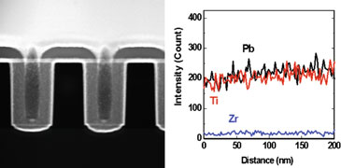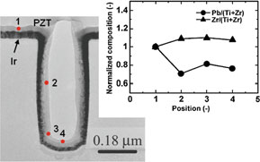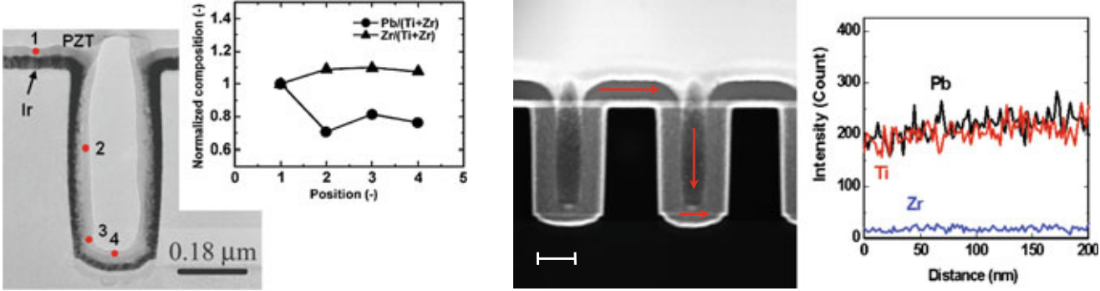

162 S. Hoffmann-Eifert and T. Watanabe

the transition metal sources, Ti(Oi–Pr)2(TMHD)2 was chosen for the Ti source. Although ALD processes were established for all three binary oxides, the combination of the ALD processes into a nano-laminate process for PZT at about 240 �C suffered from two drawbacks. First, the metal sources displayed a strong interdepen-dence of the deposition rates of the cations in the deposited amorphous layer. This further resulted in a variation of the cation composition when a Pb–Zr–Ti–O-containing film was grown into a 3D pinhole structure (see Fig. 6.9a). In addition, the films were lead-deficient and the Zr content could not be raised much above 10 at % [46].

System 2. The interdependence of the deposition rates among the three sources was primarily attributed to a possible cross reaction between the lead and the titanium source, because the Zr content of the grown layers was below 10 %. Thus, a titanium source was sought which is more compatible with the standard lead source Pb(TMHD)2 with respect to its thermal properties. The replacement of the stabilized titanium source by the pure alkoxide Ti(Oi–Pr)4, while maintaining Pb(TMHD)2 and Zr(TMHD)4 as the respective cation precursors, significantly improved the stability of the ALD process by reducing correlation effects in the growth of the binary oxide layers. The lead content in the films was slightly below the stoichiometric composi- tion. Amorphous Pb–Zr–Ti–O-containing films deposited into 3D hole structures revealed good conformity and constant stoichiometry even for hole diameters of 0.18 lm (see Fig. 6.9b). The drawback of the process was the low deposition rate of Zr–O under the compatible process conditions, keeping the Zr content of the films below 10 at %.

**(a)**  **(b)**

**LS2**   
**LS1**

**LS2**

|  |  |
| --- | --- |
| 100 nm | **LS3** |

Fig. 6.9 a TEM cross-sectional image of an ALD PZT film grown from Pb(TMHD)2, Ti(Oi–Pr)2(TMHD)2, Zr(TMHD)4, and H2O on an ALD Ir-coated SiO2 pinhole structure (top) and the local cation composition of the PZT film normalized to the composition at the top flat surface. b STEM cross-sectional image of an ALD PZT film grown from Pb(TMHD)2, Ti(Oi–Pr)4, Zr(TMHD)4, and H2O on an ALD Ir film-coated SiO2 pinhole structure of 0.18 lm diameter (top) and EDS line scan profiles taken along the sidewall (Reprinted with permission from [46].

Copyright 2007, The Electrochemical Society.)

|  |  |  |
| --- | --- | --- |
| 6 | FeRAM | 163 |

Crystallized Zr-doped PbTiO3 films showed piezoelectric properties

but the leakage current of the films was too high to measure the FE

properties [46].

System 3. The third change addressed the zirconium precursor in order to

achieve a higher Zr content in the resulting PZT films. For b-

diketonate compounds, the thermal decomposition temperature and

the vapor pressure change with a variation of the ligand structure. The

b-diketonate Zr compounds with symmetric ligands, namely

Zr(TMHD)4 and Zr(DIBM)4, show good thermal stability, while the

vaporization rate of the latter was found to be higher by approximately

a factor of eight compared to the standard TMHD compound [60]. The

higher vaporization rate of the Zr(DIBM)4 precursor indeed resulted in

an increase of the growth rate of LI-ALD ZrO2 thin films by a factor of

three [50]. The ALD multicomponent oxide process from

Pb(TMHD)2, Ti(Oi–Pr)4, Zr(DIBM)4, and water at 240 �C substrate

temperature showed stable saturation behavior for all binary processes

irrespective of whether the other respective compounds were varied.

The deposition process allowed the [Zr]/([Ti] ? [Zr]) ratio to be

adjusted up to 0.5, while the [Pb]/([Ti] ? [Zr]) composition was

stable at a slightly Pb-rich value of about 1.2. Details of the deposition

process are described in Ref. [50]. Scanning transmission electron

microscopy (STEM) analysis of amorphous ALD PZT thin films

grown into 3D pinhole structures of 0.18 lm in diameter showed an

excellent step coverage and conformity and a constant [Pb]/

([Ti] ? [Zr]) stoichiometry along the top, side wall, and bottom of

the pinhole structure (see Fig. 6.10) [50].

Hence, an ALD-type process for the conformal deposition of Pb–Zr–Ti–O-

containing films was successfully developed. This process involves pulsed spray

evaporation of the liquid precursors, which are Pb(TMHD)2, Ti(Oi–Pr)4, and

Zr(DIBM)4 dissolved in ethylcyclohexane at a concentration of 0.05 mol per liter.

The vaporizer temperature was set to 200 �C. Water vapor was used as the oxygen

source, and Ar was used for purging. The reactor pressure was fixed at 1.0 Torr,

and the substrate temperature was set to 240 �C which is below the decomposition

temperature of the precursors.

The exact stoichiometry of the ALD PZT films was analyzed for corresponding

films deposited on planar Pt(111)/AlOx/SiOx/Si substrates. The formation of a

PbPtx alloy [61] was not observed for the pulsed LD ALD PZT process. This is

attributed to the low deposition temperature of 240 �C, which is lower than the

stability regime of the PbPtx phase. The composition of the ALD PZT films grown

on the planar substrates was analyzed by means of X-ray fluorescence spectros-

copy (XRF). The [Zr]/([Zr] ? [Ti]) composition in the Pb–Zr–Ti–O films was

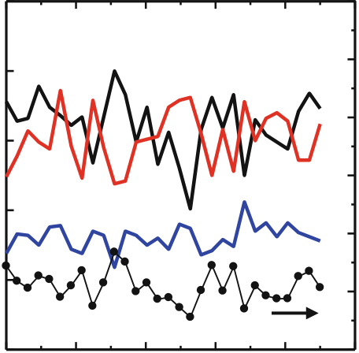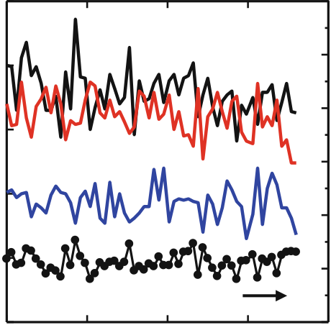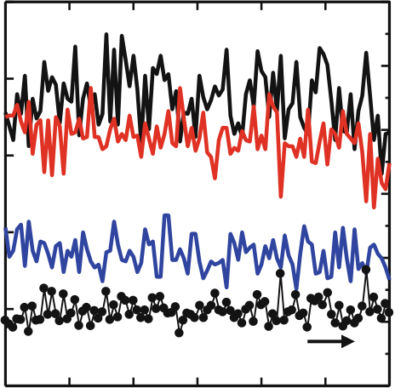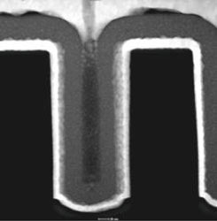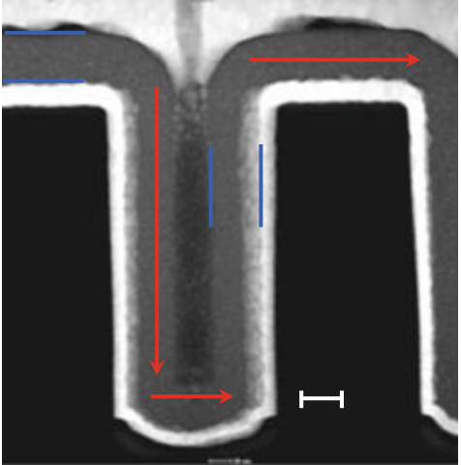

|  |  |  |  |  |  |  |  |  |  |  |  |  |  |  |  |  |  |  |  |  |  |  |  |
| --- | --- | --- | --- | --- | --- | --- | --- | --- | --- | --- | --- | --- | --- | --- | --- | --- | --- | --- | --- | --- | --- | --- | --- |
| 164 | **250** | **(a)** | | | | | | | **Intensity ratio, Pb/Ti (-)** | **(b)** | | **0** | S. Hoffmann-Eifert and T. Watanabe | | | | | | | | | | |
| **Zr** | | **Pb** | | | **LS1** | | **6** | | | **Intensity ratio, Pb/Ti (-)** |
| **250** | |
| **LS1** | | | **LS3** | | | |
| **200** | | **5** | | |
| **Intensity (Count)** | **150**  **100**  **50** | **4** | | |
| **Ti** | | |
| **3** | | |
| **LS2** | | | **40 nm** | | | |
| **2** | | |
| **Pb/Ti** | | |
| **1** | | |
| **0** | |
| **50** | **100** | **150** | | **200** | | **250** | **0**  **300** | | | |
| **(c)** | | | | | | | **(d)** | | **Distance (nm)** | | | | | | | | | | |
| **Zr** | | **Pb** | **LS3** | | | | | **6** | **Intensity ratio, Pb/Ti (-)** | |
| **6** | | | | | | | **250** | |
| **Pb** | | | **LS2** | | | **5** |
| **200** | **200** | | **5** |
| **Intensity (Count)** | **150** | **4** | | | | | | | **Intensity (Count)** | **150**  **100**  **50** | **0** | **Ti** | **4** |
| **Zr** | **Ti** | | **3** | | | | **3** |
| **100** |
| **2** | | | | **2** |
| **Pb/Ti** |
| **50** |
| **1** | | | | | | | **1** |
| **0** | **0** | **20** | **Pb/Ti** | **60** | **80** | **0 100** | | **0** | |
| **50** | | **100** | **150** | | | | **0**  **200** | | | |
| **40** |
| **Distance (nm)** | | | | | | | **Distance (nm)** | | | | | | | | | | |

Fig. 6.10 a STEM cross-sectional image of an ALD PZT film grown from Pb(TMHD)2, Ti(Oi–Pr)4, Zr(DIBM)4, and H2O on an ALD Ir-coated SiO2 pinhole structure of 0.18 lm diameter and (b–d) EDS line scan profiles taken at three specific positions shown in (a) (Reprinted with permission from [50]. Copyright 2008, The Electrochemical Society.)

adjusted by the number of Zr–O cycles during one total Pb–O/Zr–O/Ti–O cycling sequence, while the [Pb]/([Zr] ? [Ti]) ratio stabilized at a value of about 1.2 irrespective of the Zr content (see Figs. 6.11 a, b). This process window, which was attributed to the limited chemisorption sites on the growing Pb–O surface for the Zr(DIBM)4 and Ti(Oi–Pr)4 molecules, enables an adjustment of the Zr/Ti composition of the ALD PZT films as required by the application. The excess of PbO of about 20 % in the as-deposited amorphous films is advantageous because it can compensate the PbO loss during high-temperature annealing for crystallization of the film into the FE perovskite phase. A PbO-rich amorphous phase may help to suppress crystallization into the Pb-deficient non-FE pyrochlore-type phase.

Another report on ALD of PbO and PbTiO3 films using a nitrogen containing lead precursor, Pb(DMAMP)2 (DMAMP = bis(3-N,N-dimethylamino-2-methyl-2-propoxide)), and Ti(Oi–Pr)4 was given by Lee et al., where an unusual growth behavior depending on the cation composition ratio was found [43].

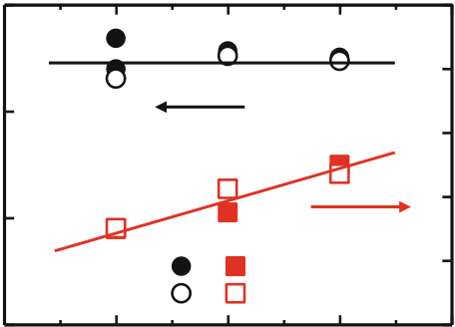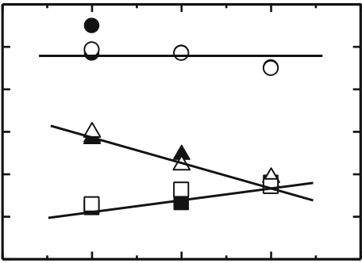

|  |  |  |  |  |  |  |  |  |  |  |  |  |  |  |  |
| --- | --- | --- | --- | --- | --- | --- | --- | --- | --- | --- | --- | --- | --- | --- | --- |
| 6 | FeRAM | | | | | | **1** | **Composition, Zr/(Zr+Ti)** | **(b)** | **3** | **0** | **Pb** | | | 165 |
| **(a)** | | | | | | |
| **Composition, Pb/(Zr+Ti)** | **1.5** | **0** | **1** | **2** | **40 sequences 80 sequences** | | **Deposition rate**  **(10-9mol/cm2·sequence)** |
| **0.8** | **2.5** |
| **1** |
| **2** |
| **0.6** | **Ti** | | |
| **1.5** |
| **0.5** | **0.4** |
| **1** | **Zr** | | |
| **0.2** |
| **0.5** |
| **0** | **3** | **4** | **0** | **0** | **1** | **2** | **3** | **4** |
| **Number of Zr-O cycle (-)** | | | | | | | **Number of Zr-O cycle (-)** | | |

Fig. 6.11 Film composition (a) and deposition rates (b) as a function of the repetition numbers of the Zr–O cycles in one Pb–O/n Zr–O/Ti–O sequence. The ALD PZT film was grown from Pb(TMHD)2, Ti(Oi–Pr)4, Zr(DIBM)4, and H2O. (Reprinted with permission from [50]. Copyright 2008, The Electrochemical Society.)

6.4.3 Crystallization of ALD PZT Films

Amorphous ALD PZT films with 70 nm thickness were grown on planar Pt-coated

|  |  |  |  |  |  |  |  |  |  |
| --- | --- | --- | --- | --- | --- | --- | --- | --- | --- |
| Si | substrates. | The | compositional | ratios | measured | by | XRF | were | [Pb]/ |

([Zr] ? [Ti]) = 1.2 and [Zr]/([Zr] ? [Ti]) = 0.47. The ALD PZT films were crystallized in a two-step annealing process, i.e., 400 �C for 30 min and subse-quently 700 �C for 10 nm in oxygen [50]. X-ray diffraction analysis revealed the formation of a single-phase perovskite structure with almost random crystal ori-entation (see Fig. 6.12a). No peaks were detected from the pyrochlore phase. Platinum circular electrodes with a diameter of 250 lm were deposited by sput-tering through a shadow mask. After postmetallization annealing at 400 �C for 10 min the FE hysteresis of the planar Pt/70 nm ALD-PZT/Pt capacitor was recorded using a 100 Hz triangular wave (see Fig. 6.12b). For the remanent polarization (2Pr) and the coercive field (2Ec), values of about 24 lC/cm2and 200 kV/cm were determined, respectively [50].

6.4.4 Nanostructure Analysis of ALD PZT Films

Although the ALD PZT thin films in the as-deposited state were amorphous under X-ray diffraction analysis, they might contain nano-size crystallites which are too small to be detected by standard XRD techniques. However, the information on the nanostructure of the multicomponent ALD films in the as-deposited state is of great importance for understanding the ALD process and for optimizing the crystallization process into the FE perovskite structure. Therefore, a high-resolu-tion transmission electron microscopy (HRTEM) study and STEM analysis were performed on an ALD PZT film grown from Pb(TMHD)2, Ti(Oi–Pr)4, Zr(DIBM)4, and H2O at 240 �C on ALD Ir-coated SiO2. These studies on the nanoscale

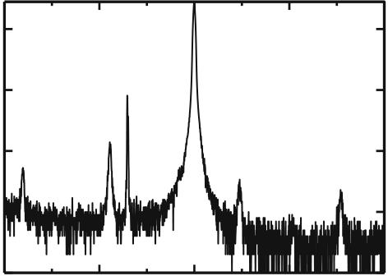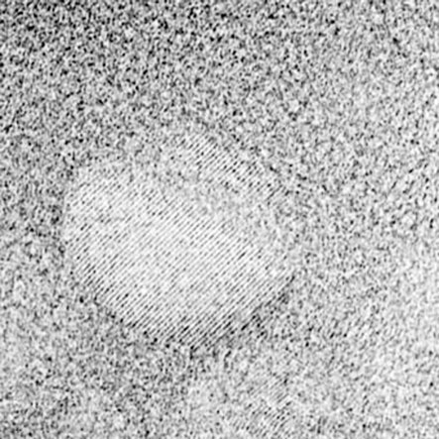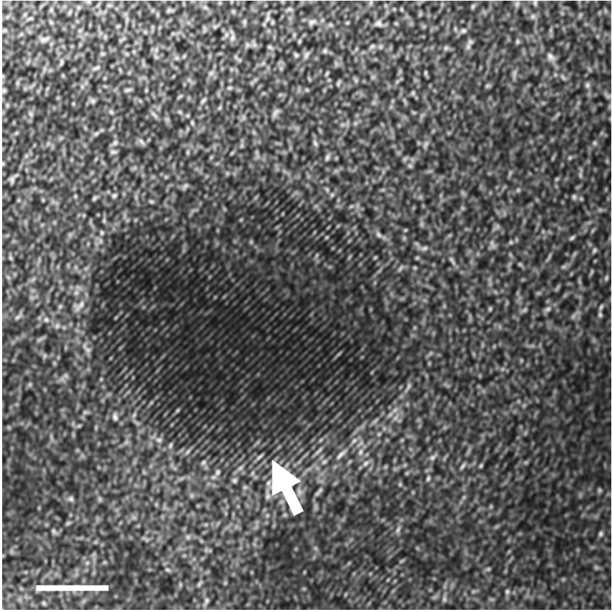

|  |  |  |  |  |  |  |  |  |  |  |  |  |  |  |  |  |  |
| --- | --- | --- | --- | --- | --- | --- | --- | --- | --- | --- | --- | --- | --- | --- | --- | --- | --- |
| 166 | **(a)** | | 110/101 | Sub. | 111 Pt | 200/002 | 210/201 | 112/211 | **60** | **(b)**   **60 Polarization ( C/cm2)**   **40**  **20**  **0** **-20** **-40** **-60** | S. Hoffmann-Eifert and T. Watanabe | | | | | | |
| **Intensity (Arb. unit)** | 100/001 |  | | | | | | |
| **20** | | **30** | **40** | | **50** | | **-6** | **-4** | **-2** | **0** | **2** | **4** | **6** |
| **2 , CuK (deg.)** | | | | | **Applied voltage (V)** | | | | | | |

Fig. 6.12 a XRD pattern of an ALD PZT film (t = 70 nm, [Pb]/([Zr] ? [Ti]) = 1.2, [Zr]/ ([Ti] ? [Zr]) = 0.47 deposited at 240 �C) after annealing at 400 �C for 30 min and at 700 �C for 10 min. bP–V hysteresis loop of the PZT film in (a) with Pt circular top electrodes of 0.25 mm diameter. (Reprinted with permission from [50]. Copyright 2008, The Electrochemical Society.)

Fig. 6.13 HRTEM image of

an as-deposited ALD PZT film grown at 240 �C from Pb(TMHD)2, Ti(Oi–Pr)4, Zr(DIBM)4, and H2O on ALD Ir-coated SiO2. The image reveals a nano

**Amorphous Ti-Zr-O**

composite-type structure of   
PbOx nano-crystals   
embedded in an amorphous   
Ti–Zr–O matrix. (Reprinted   
with permission from [50].

Copyright 2008, The   
Electrochemical Society.)

**5 nm**  **Crystallized Pb(O)**

revealed that the as-deposited ALD PZT film contained an amorphous Ti–Zr–O matrix with a homogeneous distribution of titanium and zirconium with embedded nanoclusters of PbOx [50]. Figure 6.13 shows the HRTEM micrograph of a single PbOx nanocrystallite with a diameter of about 10 nm embedded in the amorphous Ti–Zr–O matrix.Unfortunately, the size of the crystallites was too small to identify the PbOx phase, i.e., to determine of x. It has to be mentioned that HRTEM studies on an as-deposited ALD PZT film grown from Pb(TMHD)2, Ti(Oi–Pr)4, Zr(TMHD)4, and H2O at 240 �C on ALD Ir-coated SiO2 did not reveal a com-parable nano composite structure. Thus, the comparison of the film nanostructures

|  |  |  |
| --- | --- | --- |
| 6 | FeRAM | 167 |

with the film compositions shows that the film from ALD system 2 with excess Ti content and under stoichiometric Pb content exhibits an amorphous nanostructure, while the film from ALD system 3 with nearly the same Ti and Zr content and over stoichiometric Pb content shows a nano composite structure. These observations may point toward key features for a further understanding of the growth and crystallization of ALD PZT thin films. Nevertheless, a deeper discussion on the possible role of the PbOx nanocrystallites in the crystallization process of the ALD PZT films was beyond the scope of this case study and would be too speculative. It must therefore be postponed for future investigations together with a crystalliza-tion study of the ALD PZT thin films in 3D device-type structures.

Within the scope of a case study, ALD-type processes for the multi-component FE oxide Pb(ZrxTi1-x)O3 based on a combination of binary oxide processes uti-lizing different alkoxide and b-diketonate-type precursors were successfully demonstrated. Additionally, conformality and compositional homogeneity were demonstrated for films grown into capacitor pinhole structures of 0.18 lm in diameter.

6.5 Trends in Ferroelectric Field Effect Transistors

FeFET utilizes a thin FE oxide layer to replace the gate oxide. This enables the source-drain current to be controlled by varying the polarization state in the FE oxide. Hence, the FeFET represents a nonvolatile FE memory device with highest integration density, which enables a nondestructive read-out of the stored infor-mation, i.e., the orientation of the polarization [62]. Recently, research on FeFET devices experienced renewed interest after the successful integration of high-k oxides, such as HfO2, as gate dielectrics. One of the key factors for this evolution is the availability of ALD processes enabling the deposition of an oxide layer without a severe degradation of the transistor channel properties. A modified ALD PZT process was recently reported for the fabrication of integrated metal-FE-insulator-semiconductor diodes [63]. Another exciting trend was the discovery of ferroelectricity in silicon-doped HfO2 and ZrO2 thin films. A closer investigation revealed that the doping stabilizes an orthorhombic state of the binary oxide which is FE [64]. Especially, the proven compatibility of these oxides makes them attractive for integration into FeFETs, which is reflected by increased activities in this field [65].

Acknowledgments The authors thank Prof. C.S. Hwang (Seoul National University, Korea) and Prof. R. Waser and Dr. U. Böttger (RWTH Aachen University, Germany) for fruitful discussions. Thanks is also to S. Carella, L. Cataneo (SAES Getters SEA, Italy), and Dr. Y. Tasaki (Toshima MfG Co., Ltd., Japan) for precursor supply and discussion, Samsung Advanced Institute of Technology (SAIT, Korea) for supply of the 3D substrates, Dr. A. Besmehn, Dr. S. Willbold, and W. Krumpen (ZCH, FZJ, Germany) for chemical analysis, M. Gebauer and M. Gerst (PGI-7, FZJ) for technical support, Dr. H.-J. Penkalla and D. Esser (IEK-2, FZJ) for FIB lamellae

168 S. Hoffmann-Eifert and T. Watanabe

preparation, and Dr. T. Weirich and F. Dorn (GFE, RWTH Aachen University) for STEM and HRTEM analysis. T.W. also extends thanks to the Alexander von Humboldt Stiftung (AvH) for awarding him a research fellowship.

References

1. Böttger U, Summerfelt SR (2005) Ferroelectric random access memories. In: Waser R (ed) Nanoelectronics and Information Technology, WILEY-VCH Verlag GmbH & Co. KGaA, Berlin, pp 565–589   
2. Scott JF, Paz-de-Araujo CA (1989) Ferroelectric memories. Science 246:1400–1405 3. Koike H, Otsuki T, Kimura T, Fukuma M, Hayashi Y, Maejima Y, Amanuma K, Tanabe N, Matsuki T, Saito S, Takeuchi T, Kobayashi S, Kunio T, Hase T, Miyasaka Y, Shohata N, Takada M (1996) A 60 ns 1 Mb nonvolatile ferroelectric memory with non-driven cell plate line write/read scheme. In: 1996 IEEE international solid-state circuits conference, Digest of Technical Papers 39, pp 368–369   
4. Takashima D, Kunishima I (1998) High-density chain ferroelectric random access memory (chain FRAM). IEEE J Solid State Circ 33:787–792   
5. Sheikholeslami A, Gulak PG (2000) A survey of circuit innovations in ferroelectric random- access memories. Proc IEEE 88:667–689   
6. Park SO, Bae BJ, Yoo DC, Chung U-I (2008) Ferroelectric random access memory. In: Waser R (ed) Nanotechnology, vol 3: Information Technology I. Wiley-VCH Verlag GmbH & Co. KGaA, Weinheim, pp 397–418   
7. Kim HH, Song YJ, Lee SY, Joo HJ, Jang NW, Jung DJ, Park YS, Park SO, Lee KM, Joo SH, Lee SW, Nam SD, Kim K (2002) Novel integration technologies for highly manufacturable 32 Mb FRAM. In: 2002 symposium on VLSI technology, Digest of Technical Papers, IEEE, pp 210–211   
8. Lee H, Hesse D, Zakharov N, Goesele U (2002) Ferroelectric Bi3.25La0.75Ti3O12 films of uniform a-axis orientation on silicon substrates. Science 296:2006–2009   
9. Watanabe T, Funakubo H (2006) Controlled crystal growth of layered-perovskite thin films as an approach to study their basic properties, J. Appl. Phys. 100:51602/1–11   
10. DeAraujo CAP, Cuchiaro JD, McMillan LD, Scott MC, Scott JF (1995) Fatigue-free ferroelectric capacitors with platinum electrodes. Nature 374:627–629   
11. Ramesh R (1997) Thin film ferroelectric materials and devices. Kluwer Academic Publishers, Boston   
12. Scott JF (2000) Ferroelectric memories. Springer, Berlin   
13. Okuyama M, Ishibashi Y (2005) Ferroelectric thin films, Basic properties and device physics for memory applications. Springer, Berlin   
14. Waser R, Boettger U, Tiedke S (2005) Polar oxides: properties, characterization, and imaging. WILEY-VCH Verlag GmbH & Co. KGaA, Weinheim   
15. Yokoyama S, Honda Y, Morioka H, Okamoto S, Funakubo H, Iijima T, Matsuda H, Saito K, Yamamoto T, Okino H, Sakata O, Kimura S (2005) Dependence of electrical properties of epitaxial Pb(Zr,Ti)O3 thick films on crystal orientation and Zr/(Zr ? Ti) ratio. J Appl Phys 98:94106-1-8   
16. Pertsev NA, Kukhar VG, Kohlstedt H, Waser R (2003) Phase diagrams and physical properties of single-domain epitaxial Pb(Zr1-xTix)O3 thin films. Phys Rev B (Condens Matter Mater Phys) 67:54107-1-10   
17. Qiu QY, Mahjoub R, Alpay SP, Nagarajan V (2010) Misfit strain-film thickness phase diagrams and related electromechanical properties of epitaxial ultra-thin lead zirconate titanate films. Acta Mater 58:823–835   
18. Newnham R, Wolfe R, Dorrian J (1971) Structural basis of ferroelectricity in bismuth titanate family. Mater Res Bull 6:1029

|  |  |  |
| --- | --- | --- |
| 6 | FeRAM | 169 |

19. Wouters DJ, Maes D, Goux L, Lisoni JG, Paraschiv V, Johnson JA, Schwitters M, Everaert J, Boullart W, Schaekers M, Willegems M, Vander Meeren H, Haspeslagh L, Artoni C, Caputa C, Casella P, Corallo G, Russo G, Zambrano R, Monchoix H, Vecchio G, Van Autryve L (2006) Integration of SrBi2Ta2O9 thin films for high density ferroelectric random access memory. J Appl Phys 100:51603/1–16   
20. Goux L, Maes D, Lisoni JG, Vander Meeren H, Paraschiv V, Haspeslagh L, Artoni C, Russo G, Zambrano R, Wouters DJ (2006) Scaling potential of pin-type 3-D SBT ferroelectric capacitors integrated in 0.18 lm CMOS technology. Microelectron Eng 83:2027–2031 21. Richter D, Trolier-McKinstry S (2005) Ferroelectrics. In: Waser R (ed) Nanoelectronics and information technology. WILEY-VCH Verlag GmbH & Co. KGaA, Berlin, pp 59–78 22. Ramtron and <http://www.ramtron.com>. Nonvolatile F-RAM Memory   
23. Symetrix and <http://www.symetrixcorp.com>. Trinion non-volatile memory chip in smart cards or smart tags   
24. Texas Instruments and <http://www.ti.com>. FRAM   
25. Fujitsu Ltd. (2005) Electronic devices and <http://www.fujitsu.com>. FRAM Guide Book 26. Kim H (2003) Atomic layer deposition of metal and nitride thin films: current research efforts and applications for semiconductor device processing. J Vac Sci Technol B 21:2231–2261 27. Aaltonen T, Ritala M, Tung Y, Chi Y, Arstila K, Meinander K, Leskela M (2004) Atomic layer deposition of noble metals: exploration of the low limit of the deposition temperature.

J Mater Res 19:3353–3358   
28. Hamalainen J, Hatanpaa T, Puukilainen E, Sajavaara T, Ritala M, Leskela M (2011) Iridium metal and iridium oxide thin films grown by atomic layer deposition at low temperatures.

J Mater Chem 21:16488–16493   
29. Udayakumar KR, Moise TS, Summerfelt SR, Boku K, Remack K, Rodriguez J, Arendt M, Shinn G, Eliason J, Bailey R, Staubs P (2008) Manufacturable high-density 8 Mbit one transistor-one capacitor embedded ferroelectric random access memory. Jpn J Appl Phys 47:2710–2713   
30. Gilbert S, Hunter S, Ritchey D, Chi C, Taylor D, Amano J, Aggarwal S, Moise T, Sakoda T, Summerfelt S, Singh K, Kazemi C, Carl D, Bierman B (2003) Preparation of Pb(Zr, Ti)O3 thin films by metalorganic chemical vapor deposition for low voltage ferroelectric memory.

J Appl Phys 93:1713–1717   
31. Aratani M, Oikawa T, Ozeki T, Funakubo H (2001) Epitaxial-grade polycrystalline Pb(Zr, Ti)O3 film deposited at low temperature by pulsed-metalorganic chemical vapor deposition.

Appl Phys Lett 79:1000–1002   
32. Tokita K, Aratani M, Funakubo H (2002) Effect of atmosphere during heating of substrate on the low temperature deposition of metalorganic chemical vapor deposited Pb(ZrxTi1-x)O3 thin films. Appl Phys Lett 81:898–900   
33. Asano G, Oikawa T, Funakubo H, Saito K (2003) Good ferroelectricity of Pb(Zr, Ti)O3 thin films fabricated by highly reproducible deposition on bottom Ir electrode at 395 �C. Jpn J Appl Phys 42:L1083–L1086   
34. Lee S, Kim K (2006) Current development status and future challenges of ferroelectric random access memory technologies. Jpn J Appl Phys 45:3189–3193   
35. ITRS (2007) The International Technology Roadmap for Semiconductors. 2007 edn. [http://](http://www.itrs.net/links/2007ITRS/)  [www.itrs.net/links/2007ITRS/](http://www.itrs.net/links/2007ITRS/)   
36. Park Y, Lee JH, Koo JM, Kim SP, Shin S, Cho CR, Lee JK (2004) Preparation of Pb(ZrxTi1-x)O3 films on trench structure for high-density ferroelectric random access memory. Integr Ferroelectr 66:85–95   
37. Koo J, Seo B, Kim S, Shin S, Lee J, Baik H, Lee J, Lee J, Bae B, Lim J, Yoo D, Park S, Kim H, Han H, Baik S, Choi J, Park Y, Park Y (2005) Fabrication of 3D trench PZT capacitors for 256Mbit FRAM device application. In: IEEE international electron devices meeting 2005, Technical Digest, pp 351–354   
38. Shin S, Han H, Park YJ, Choi JY, Park Y, Baik S (2007) Characterization of 3D trench PZT capacitors for high density FRAM devices by synchrotron X-ray microdiffraction, Synchrotron Radiat Instr, Pts 1 and 2 879:1554–1556

170 S. Hoffmann-Eifert and T. Watanabe

39. Shin W, Ryu S, You I, Yoon S, Cho S, Lee N, Kim K, Yu B, Lee W, Choi K, Yoon S (2004) Low voltage switching characteristics of 60 nm thick SrBi2Ta2O9 thin films deposited by plasma-enhanced ALD. Electrochem Solid State Lett 7:F31–F34   
40. Harjuoja J, Kosola A, Putkonen M, Niinisto L (2006) Atomic layer deposition and post- deposition annealing of PbTiO3 thin films. Thin Solid Films 496:346–352   
41. Harjuoja J, Vayrynen S, Putkonen M, Niinisto L, Rauhala E (2007) Atomic layer deposition of PbZrO3 thin films. Appl Surf Sci 253:5228–5232   
42. Hwang GW, Lee HJ, Lee K, Hwang CS (2007) Atomic layer deposition and electrical properties of PbTiO3 thin films using metallorganic precursors and H2O. J Electrochem Soc 154:G69–G76   
43. Lee HJ, Park MH, Min Y–S, Clavel G, Pinna N, Hwang CS (2010) Unusual growth behavior of atomic layer deposited PbTiO3 thin films using water and ozone as oxygen sources and their combination. J Phys Chem C114:12736–12741   
44. Watanabe T, Hoffmann-Eifert S, Hwang CS, Waser R (2006) Liquid-injection atomic Layer deposition of TiOx and Pb-Ti-O films. J Electrochem Soc 153:199–204   
45. Watanabe T, Hoffmann-Eifert S, Mi S, Jia C, Waser R, Hwang CS (2007) Growth of ternary PbTiOx films in a combination of binary oxide atomic layer depositions. J Appl Phys 101:14114/1-8   
46. Watanabe T, Hoffmann-Eifert S, Peter F, Mi S, Jia C, Hwang CS, Waser R (2007) Liquid injection ALD of Pb(Zr,Ti)Ox thin films by a combination of self-regulating component oxide processes. J Electrochem Soc 154:G262–G269   
47. Watanabe T, Hoffmann-Eifert S, Waser R, Hwang CS (2007) Atomic layer deposition of Pb(Zr,Ti)Ox thin films by a combination of binary atomic layer deposition. In: Proceedings of the 2006 15th IEEE international symposium on applications of ferroelectrics. IEEE, Piscataway, pp 89–92   
48. Watanabe T, Hoffmann-Eifert S, Waser R, Hwang CS (2007) Liquid injection atomic layer deposition of Pb(Zr,Ti)O3 thin films on three dimensional structures, In: Proceedings of the 2007 16th ieee international symposium on applications of ferroelectrics. IEEE, Piscataway, pp 156–158   
49. Hoffmann-Eifert S, Watanabe T, Hwang CS, Waser R (2008) Liquid injection atomic layer deposition of perovskite-type multi-component oxide thin films for ferroelectric and higher-k three dimensional capacitor structures. 2008 17th IEEE international symposium on the applications of ferroelectrics, IEEE, Piscataway, pp 446–447   
50. Watanabe T, Hoffmann-Eifert S, Hwang CS, Waser R (2008) Growth behavior of atomic- layer-deposited Pb(Zr, Ti)Ox thin films on planar substrate and three-dimensional hole structures. J Electrochem Soc 155:D715–D722   
51. Vehkamaki M, Ritala M, Leskela M, Jones AC, Davies HO, Sajavaara T, Rauhala E (2004) Atomic layer deposition of strontium tantalate thin films from bimetallic precursors and water. J Electrochem Soc 151:F69–F72   
52. Schumacher M, Baumann P, Seidel T (2006) AVD and ALD as two complementary technology solutions for next generation dielectric and conductive thin-film processing.

Chem Vapor Depos 12:99–108   
53. Watanabe T, Hoffmann-Eifert S, Yang L, Ruediger A, Kuegeler C, Hwang CS, Waser R (2007) Liquid injection atomic layer deposition of TiOx films using Ti[OCH(CH3)2]4.

J Electrochem Soc 154:G134–G140   
54. Shin J, Hong S, Lee J, Cho H, Kim K, Hwang C, Kim H (1998) Preparation and characterization of (Pb, La)TiO3 thin films by solid source mixture metal organic chemical vapor deposition. J Kor Phys Soc 32:S1529–S1531   
55. Kim SK, Hoffmann-Eifert S, Reiners M, Waser R (2011) Relation between enhancement in growth and thickness-dependent crystallization in ALD TiO2 thin films. J Electrochem Soc 158:D6–D9   
56. Kim SK, Hoffmann-Eifert S, Mi S, Waser R (2009) Liquid injection atomic layer deposition of crystalline TiO2 thin films with a smooth morphology from Ti(O-iPr)2(DPM)2.

J Electrochem Soc 156:D296–D300

|  |  |  |
| --- | --- | --- |
| 6 | FeRAM | 171 |

57. Aarik J, Aidla A, Uustare T, Ritala M, Leskela M (2000) Titanium isopropoxide as a precursor for atomic layer deposition: characterization of titanium dioxide growth process.

Appl Surf Sci 161:385–395   
58. Jones AC, Hitchman ML (2009) Chemical vapor deposition: precursors, processes and applications. Royal Social of Chemistry, RSC Publishing, Cambridge; ISBN: 978-0-85404- 465-8   
59. Si J, Desu S, Tsai C (1994) Metal-organic chemical-vapor-deposition of ZrO2 films using Zr(THD)4 as precursors. J Mater Res 9:1721–1727   
60. Cattaneo L, Carella S (2007) SAES Getters Inc. and Italy, (unpublished data)   
61. Zhao JS, Lee HJ, Lee K, Sim JS, Hwang CS (2006) Influence of the Pt top electrode annealing procedure on the ferroelectric property of MOCVD Pb(Zr0.2Ti0.8)O 3 thin films.

Electrochem Solid-State Lett 9:F69–F72   
62. Kohlstedt H, Ishiwara H (2005) Ferroelectric field effect transistors. In: Waser R (ed) Nanoelectronics and information technology. WILEY-VCH Verlag GmbH & Co. KGaA, Berlin, pp 387–405   
63. Zhang F, Perng YC, Choi JH, Wu T, Chung TK, Carman GP, Locke C, Thomas S, Saddow SE, Chang JP (2011) Atomic layer deposition of Pb(Zr,Ti)Ox on 4H-SiC for metal- ferroelectric-insulator-semiconductor diodes. J Appl Phys 109:124109/1-4   
64. Boescke TS, Mueller J, Braeuhaus D, Schroeder U, Boettger U (2011) Ferroelectricity in hafnium oxide. Appl Phys Lett 99:102903   
65. Mueller J, Boescke TS, Schroeder U, Hoffmann R, Mikolajick T, Frey L (2012) Nanosecond polarization switching and long retention in a novel MFIS-FET based on ferroelectric HfO2.

IEEE Electron Device Lett 33:185–187